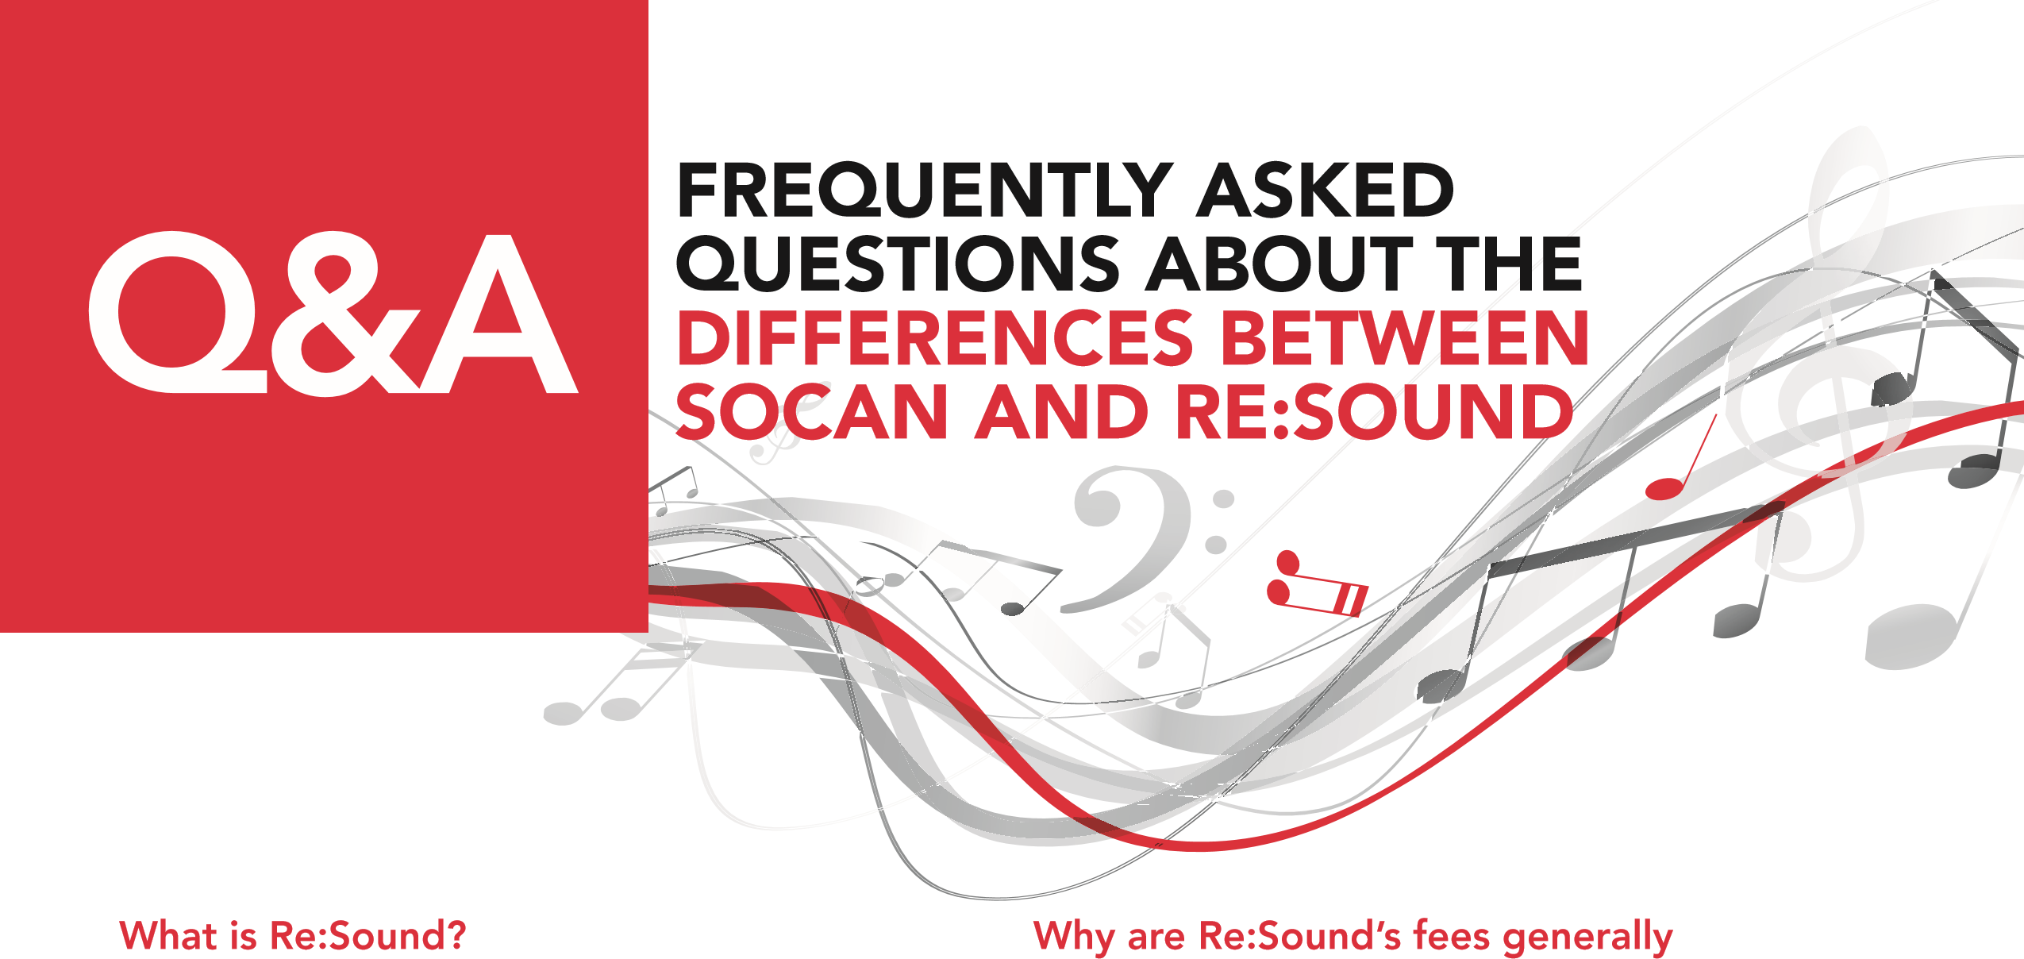
Re:Sound (formerly known as the Neighbouring Rights Collective of Canada or “NRCC”) is a Canadian copyright collective that seeks to obtain equitable remuneration for music performers and record companies by licensing the use of recorded music for public performance and broadcast.
What’s the difference between Re:Sound and SOCAN?
SOCAN represents the rights of songwriters, lyric authors, composers, and music publishers, while Re:Sound represents the rights of the performers who played on recordings and the record companies that released those recordings. SOCAN and its predecessors have existed in Canada for over 80 years, while Re:Sound is a relatively new company, founded in 1997 after amendments to Canada’s Copyright Act. What is the right to equitable remuneration?
It is the right of music performers and record companies to be paid fairly for the public performance and broadcast of their recorded musical works. This right is sometimes referred to as a “neighbouring right”.
Why do we have to pay Re:Sound if we already pay SOCAN
Both Re:Sound and SOCAN collect separate and distinct performance rights licence fees. In cases where both Re:Sound and SOCAN tariffs apply to the same business, that business must pay both collectives separately, in accordance with each one’s tariffs. When you pay SOCAN, you are paying the necessary public performance licence fees to songwriters, lyric authors, composers and music publishers. When you pay Re:Sound, you are paying the necessary public performance licence fees to the performers and makers of sound recordings. Paying one collective does not exempt you from paying the other.
lower than SOCAN’s?
Re:Sound’s tariff rates are generally lower than SOCAN’s because they apply to different rights that have been valued differently by the Copyright Board of Canada. Unlike SOCAN that represents virtually the entire world’s repertoire of Copyrighted-protected music, Re:Sound represents a limited repertoire that excludes most recordings made in countries that are not part of the WIPO Rome Convention.
Does Re:Sound have the right to collect fees retroactively (for past years)? Yes, but only when approved to do so by Canada’s Copyright Board. Re:Sound’s Tariff 5 was approved retroactive to 2008. As such, Re:Sound has the right to collect licence fees under that tariff back to January 1, 2008.
Do Re:Sound’s tariffs apply to live music?
No, Re:Sound only deals with the public performance or broadcast of recorded music.
Why is Re:Sound’s Tariff 5 titled “Use of Music to Accompany Live Events”?
It is called that because it applies to recorded music publicly performed at live events rather than music performed live and in-person such as a live performance by a band at a concert venue. By law, Re:Sound may only seek equitable remuneration in relation to the public performance or broadcast of recorded music, not live performances by musicians. Don’t let the word “live” confuse you.
IF YOU HAVE FURTHER QUESTIONS ABOUT SOCAN LICENSING, PLEASE CONTACT SOCAN at 1.866.944.6210 or licence@socan.ca.

